Problem Statement
ShoeFly.com needs concise aggregate statistics on (1) order prices and product mix, (2) website traffic by UTM source and month, and (3) click-through rates of two ad creatives (A vs B) across platforms and days of the week. Missing values exist in the order file; results must be communicable to executives, analysts and nonspecialists.

Solution Strategy
Use dplyr’s summarize / group_by / filter-with-group-metric / mutate-with-group-metric pipeline. First compute overall means and maxima (with na.rm = TRUE), then break them down by shoe_type, colour and material. For ads, count views and clicks by utm_source and experimental_group, convert counts into percentages, and compare daily CTRs. Validate with base-R alternates and a parameterised simulation (threshold, sample fraction, price noise). Adapt language to audience data-literacy and subject knowledge.

Solution

Key numeric results
- Mean order price ≈ $287 (max ≈ $470); 6 distinct shoe colours; sneakers are the most frequent type.
- Traffic sources (page visits): Facebook & Yahoo largest; email smallest.
- Ad CTR by platform: Facebook 35.7 %, Google 35.1 %, Email 31.4 %, Twitter 30.7 %.
- Experiment split balanced (≈828 A / 826 B). Overall CTR: Ad A ≈ 34.7 %, Ad B ≈ 33.7 % → modest preference for A.
- Simulation: A > B edge remains under 50 % sub-sampling; popular-shoe filter is sensitive to the n > k threshold.

Process flowchart
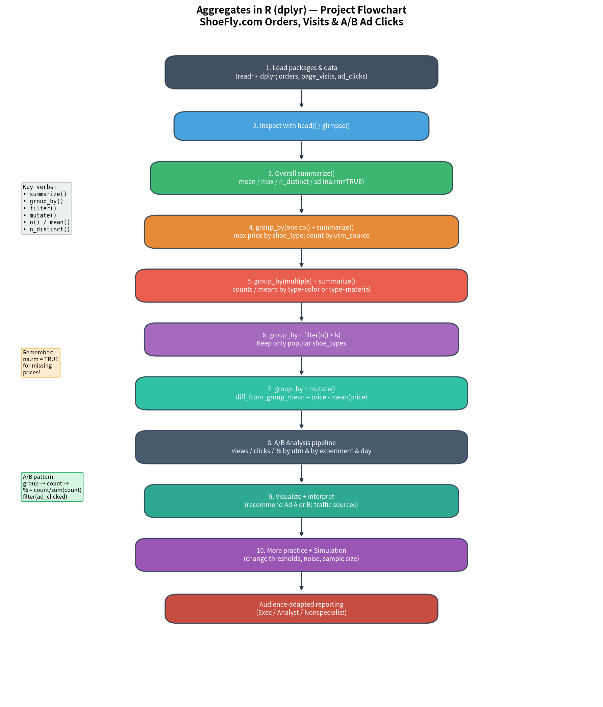

Key Takeaways
- Pattern mastery: summarize collapses; group_by + summarize collapses per group; group_by + filter keeps whole groups; group_by + mutate adds group metrics while preserving rows.
- Always handle missingness: na.rm = TRUE is mandatory when a column can contain NAs.
- A/B rates: count → percentage = count / sum(count) → filter to the event of interest is the universal rate pattern.
- Audience adaptation: Executives need the headline and recommendation; analysts need the pipeline and diagnostics; nonspecialists need plain definitions and analogies.
- Recommendation for ShoeFly: Prefer Ad A; prioritise Facebook & Google traffic; re-check day-of-week stability before full rollout.

